School Uniform

- Black leather shoes or plain black trainers (no logos, no plimsolls), securely tied or fastened with black shoelaces.
- Plain black or grey trousers/skirt (girls may wear grey trousers)
- Black belt
- Plain grey or black socks or plain tights which are black or grey
- White shirt with a collar
- School tie - worn in a business-like style (available from school priced £3.50)
- Girls of Muslim families may wear a Salwar-Kamiz, dark blue or grey, and a plain dark head scarf
- Blue Oak Lodge sweatshirt (available from school priced £12.50).

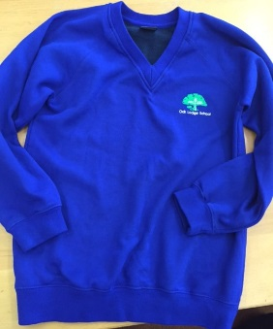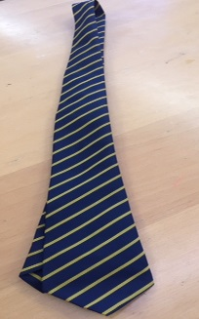

Please supply your child with a bag or case to enable him/her to carry their pens, pencils and books from room to room and to carry their homework back and forth each day.

Pupils need to provide their own pens and we encourage them to look after their own things well.

NO rings or jewellery shall be worn externally, other than sleeper-studs worn in pierced ears.
NO outdoor jackets or coats shall be worn around the school.
NO hats or caps will be worn in the school building.
NO nail varnish or false nails except on own clothes day
Are there any exceptions?

Yes, from time to time the School may relax rules in the light of particular circumstances, e.g. very hot weather, going on a school journey.

Families should consult with the School if they have cultural or religious reasons for wanting to deviate from the above.

PLEASE REMEMBER we expect children to come to school looking smart clean and tidy. So uniform and haircuts/colours should meet this requirement.

Is there a sports kit?

Yes, when doing PE or games, pupils should have: -
- Sports shoes, securely tied
- White socks
- Plain dark blue or black shorts or track-suit bottoms
- Plain white T-shirt or sports shirt
- Optional plain dark blue or black sweat-shirt or jogging top
NO watches should be worn when doing PE or games.

Hearing Aids & Cochlear Implants

We try to make sure that the children wear their hearing aids and/or cochlear implants (except when playing vigorous games). Please help us by ensuring that the child makes use of the aid at home and that he or she BRINGS THE AID TO SCHOOL EVERY DAY. Please let us know if an aid gets lost at home, or if an ear mould is painful or if your child is refusing to wear the aid.

It would be advisable to buy ties and jumpers in advance of starting in September please contact the school office on 0208 8673 3453

